Customer Satisfaction Surveys
April 2017
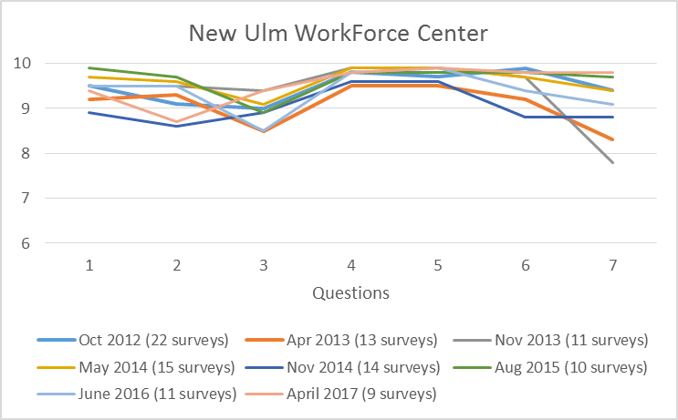
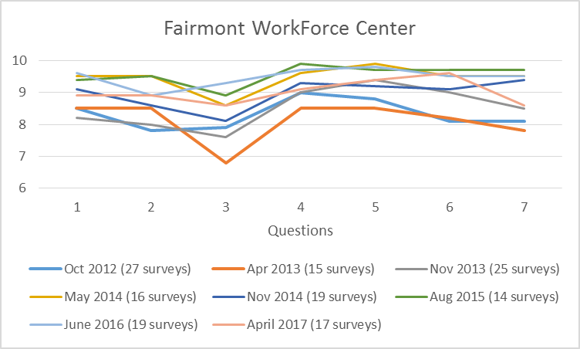
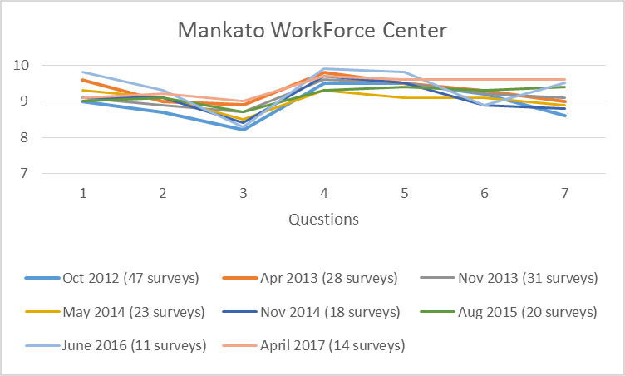
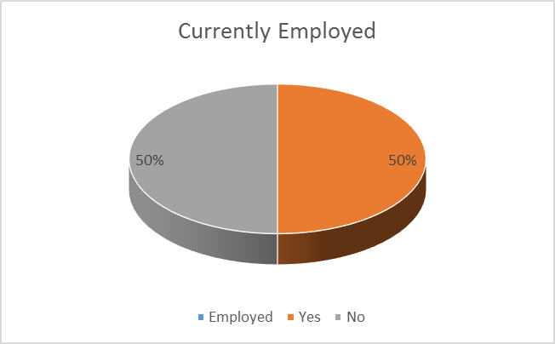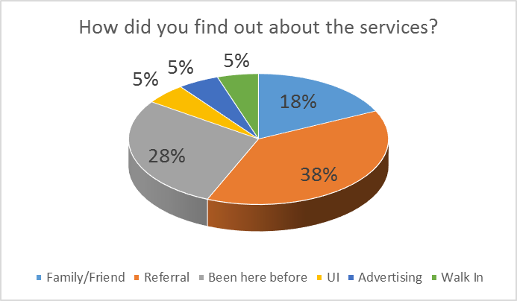

Name one thing you liked best about the services?
- If you are serious about looking for a job, this place have everything you need
- Help you find a job
- Really happy with the services
- Convenient
- Professional, friendly staff

Name one thing about the services that could be improved?
- More computers
- More funding
- More opportunities for a specific training
- Having classes on Mondays
- More sharing of information locally instead of contacting St. Paul

- Utilizing a scale of 1 to 10 where “1” means “very dissatisfied” and “10” means “very satisfied”, what is your overall satisfaction with the services provided from this WorkForce Center?
- Considering all the expectations you may have had about the services, to what extent have the services met your expectations?
- Now think about the ideal program for people in your circumstances. How well do you think the services you received compare with the ideal set of services?
- How satisfied are you that the WorkForce Center staff listened to you and respected you?
- How satisfied are you that the WorkForce Center staff was available to you when you had questions?
- How satisfied are you that the WorkForce Center staff told you about the services that are available?
- How satisfied are you that the services received today will help you find a job?

